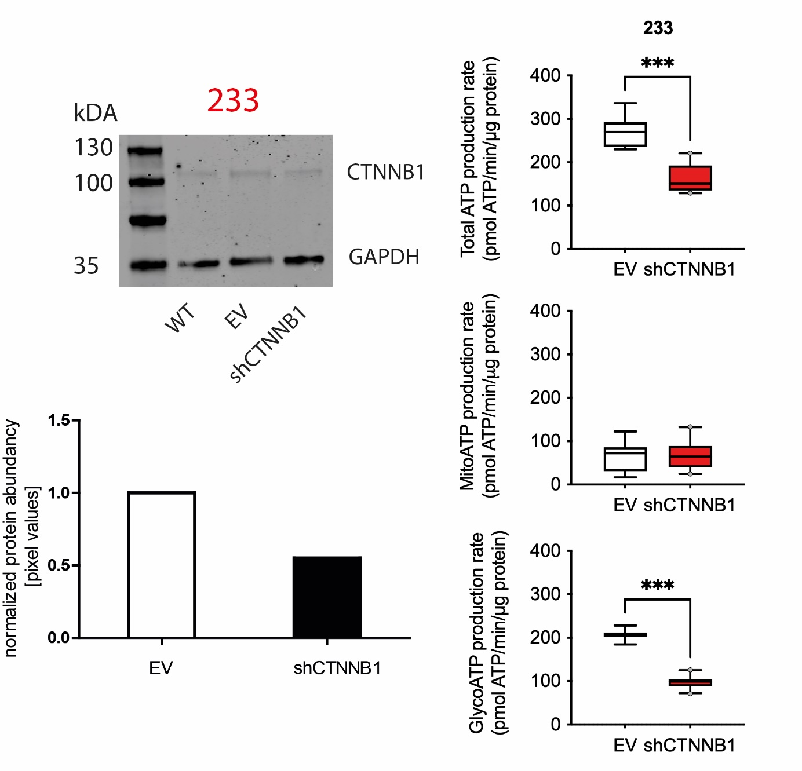
Supplementary Fig .1. Representative Western blot membrane of WNT model of glioblastoma cell line 233. Wt = wildtype, ev = empty vector, -shCTNNB1 – knockdown beta catenin.

